Sudipta mukherjee

## Assignment (30th Jan 2023)

**Question No. 1: Write a program to accept percentage from the user and display the grade according to the following criteria:**

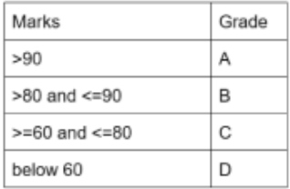

**Answer:**

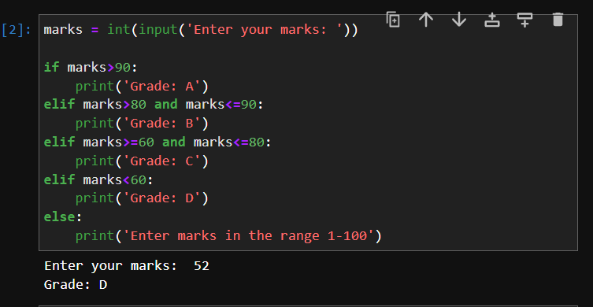

**Question No. 2: Write a program that accepts the cost price of a bike and then display the road text to be paid according to the following criteria:**

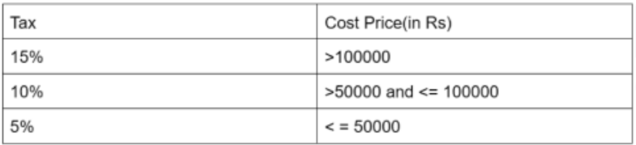

**Answer:**

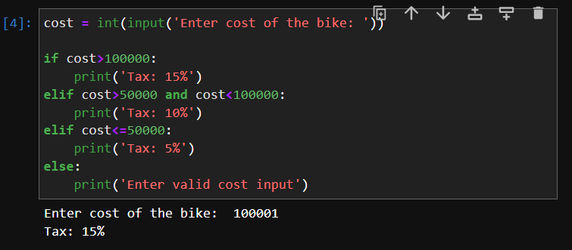

**Question No. 3: Accept any city from the user and display monument of that city.**

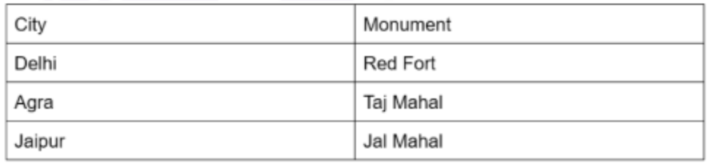

**Answer:**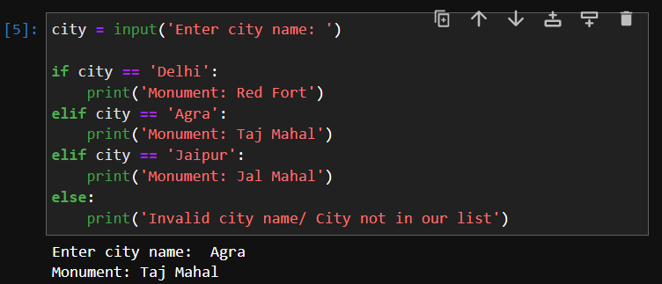

**Question No. 4: Check how many times a given number can be divided by 3 before it is less than or equal to 10.**

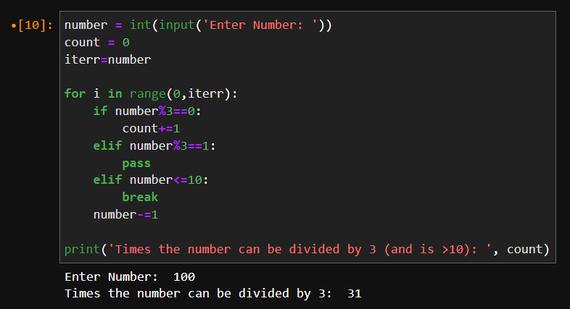

**Question No. 5: Use nested While loops to print 3 different patterns.**

**Answer:**

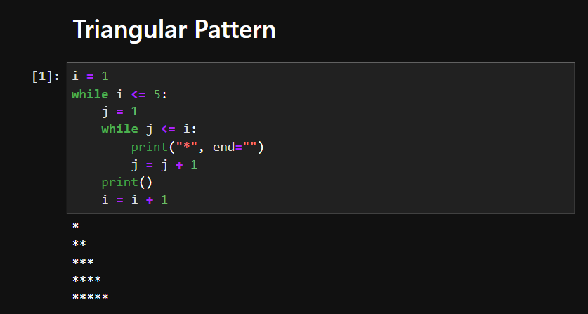

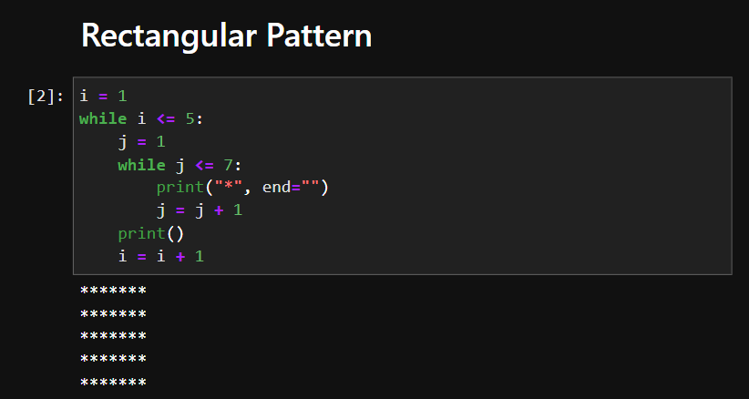

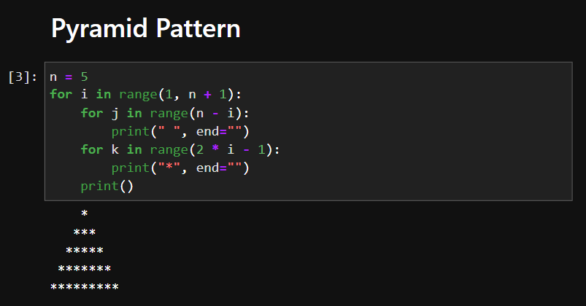

***Note: I tried to print the patterns on my own (without seeking help from the internet) but I couldn’t do it so I had to copy the code from the internet.***

**Question No. 7: Reverse a While loop to display number from 10 to 1.**

**Answer:**

